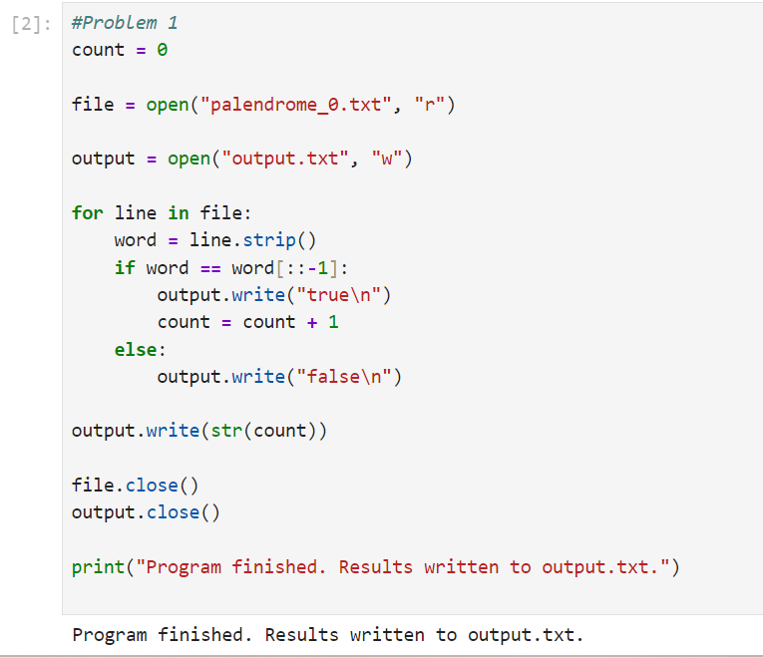

Problem2

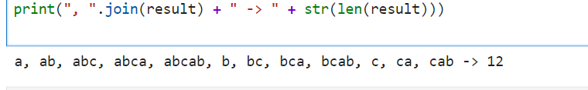

Problem3

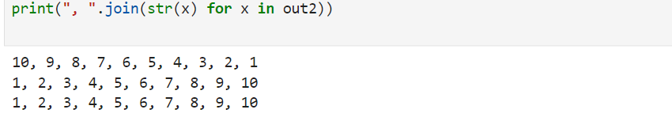

Problem4

